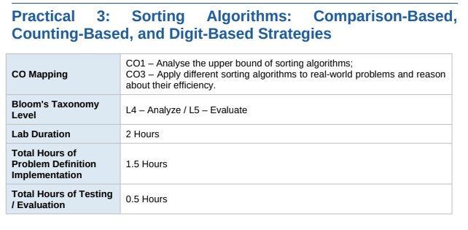
Practical Aim
To implement and compare multiple sorting algorithms and develop the ability to reason about which sorting strategy suits a given situation.
Problem 1
A teacher has a stack of student answer sheets with marks written on them and needs to arrange them in order before entering grades. She tries three different methods: in the first, she repeatedly compares adjacent sheets and swaps them if they are out of order; in the second, she finds the lowest-marked sheet each time and places it at the front; in the third, she picks each sheet one by one and inserts it into its correct position among the already-arranged sheets. Implement all three methods and for each one, print the sorted order of marks.
Describe how each of the three methods works in your own words. If the sheets were already in order before the teacher started, which method would finish the fastest and why?
Problem 2
A paint shop has buckets labeled with one of three colour codes — 0, 1, or 2 — but they are stored in a random order. The shop owner wants all 0s together, then all 1s, then all 2s, without using any extra storage. Given the list of colour codes, rearrange them in place and print theresult.
Describe the approach you used. Does your solution make more than one pass through the list?
Can you think of a way to do it in exactly one pass?
CODE:
#include <iostream>
using namespace std;

void display(int a[], int n) {
for (int i = 0; i < n; i++)
cout << a[i] << " ";
cout << endl;
}

int main() {
int a[] = {78, 45, 92, 61, 35, 88, 50};
int n = 7;

// Bubble Sort
int b[7];
for (int i = 0; i < n; i++)
b[i] = a[i];

for (int i = 0; i < n - 1; i++) {
for (int j = 0; j < n - i - 1; j++) {
if (b[j] > b[j + 1]) {
int temp = b[j];
b[j] = b[j + 1];
b[j + 1] = temp;
}
}
}

cout << "Bubble Sort: ";
display(b, n);

// Selection Sort
int s[7];
for (int i = 0; i < n; i++)
s[i] = a[i];

for (int i = 0; i < n - 1; i++) {
int min = i;

for (int j = i + 1; j < n; j++) {
if (s[j] < s[min])
min = j;
}

int temp = s[i];
s[i] = s[min];
s[min] = temp;
}

cout << "Selection Sort: ";
display(s, n);

// Insertion Sort
int in[7];
for (int i = 0; i < n; i++)
in[i] = a[i];

for (int i = 1; i < n; i++) {
int key = in[i];
int j = i - 1;

while (j >= 0 && in[j] > key) {
in[j + 1] = in[j];
j--;
}

in[j + 1] = key;
}

cout << "Insertion Sort: ";
display(in, n);

return 0;
}
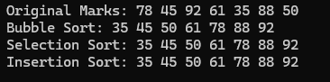
Problem 2
A paint shop has buckets labeled with one of three colour codes — 0, 1, or 2 — but they are stored in a random order. The shop owner wants all 0s together, then all 1s, then all 2s, without using any extra storage. Given the list of colour codes, rearrange them in place and print the result.
Describe the approach you used. Does your solution make more than one pass through the list?Can you think of a way to do it in exactly one pass?
CODE
#include <iostream>
using namespace std;

int main() {
int a[] = {2, 0, 1, 2, 1, 0, 2, 1, 0};
int n = 9;

int low = 0, mid = 0, high = n - 1;

while (mid <= high) {
if (a[mid] == 0) {
int temp = a[low];
a[low] = a[mid];
a[mid] = temp;
low++;
mid++;
}
else if (a[mid] == 1) {
mid++;
}
else {
int temp = a[mid];
a[mid] = a[high];
a[high] = temp;
high--;
}
}

cout << "Sorted array: ";

for (int i = 0; i < n; i++)
cout << a[i] << " ";

return 0;
}

